

Notrep01

Vers 1.0

July 2014

**Sections 95, 95A – 95F Resource Management Act 1991**

**Report determining whether an application for Resource Consent should be processed as publicly notified, limited notified or non-notified**

|  |  |
| --- | --- |
| **Consent number:** | LUC25/0001 |
| **Applicant’s Name:** | **Midlands Properties Limited** |
| **Street Address:** | Racecourse Road ASHBURTON DISTRICT |
| **Legal Description of Site:** | LOT 1 DP 568166 |
| **Zone:** | Rural A |
| **Application summary:** | Land use consent at Racecourse Road to address the non-compliances associated with the construction of two new Midlands Groups seed and plant research buildings for agricultural purposes. Zoned Rural A. |

**1.0 DESCRIPTION OF THE PROPOSAL**

The applicant is an established agricultural producer and supplier of specialist vegetable and herbage seeds, pulses, oilseeds, cereal grains, and related value-added food ingredients.

Resource consent is sought to establish a facility for seed and plant research for agricultural purposes including seed and plant trials, display of products produced, office management and administration, operational storage, site landscaping and vehicle parking. The site is located on the corner of Racecourse Road and the Methven Highway (State Highway 77) and is legally described as Lot 1 DP568166 held in Record of Title 1023645.

Components of the activity will include:

* The establishment of an administration building of approximately 600m2 in ground coverage;
* The establishment of a field office of approximately 200m2 in ground coverage;
* The establishment of trial farm plots, which will occupy approximately 5 hectares of the site;
* Operational storage facilities;
* Ancillary facilities including car parking, vehicle accessways and landscaping.
* The number of staff at the site is proposed to be 30 full time staff and various casual and ancillary staff as required for the functionality.

The proposed activity / facility will create a centralised facility that encompasses the multiple agricultural “arms” of business that Midlands has and also a substantial part of the site will be used for trials and research. It is intended that the site will act as a “flagship” facility to demonstrate both nationally and internationally, the activities Midlands undertake and to provide a facility for visitors to

come to and appreciate.

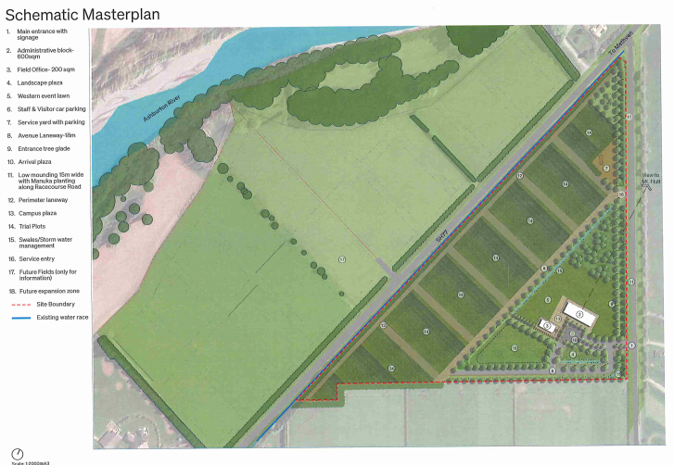

*Figure 1: Application Plan*

**1.1 DESCRIPTION OF THE EXISTING ENVIRONMENT**

The site is a 8.39 hectare triangular shaped rural property approximately 2 kilometres north of the Ashburton urban area. An aerial photograph of the site and the location of the site are illustrated in Figures 2 and 3 below. It is noted that the site also includes a small triangular 1,500m2 area of land where water is obtained for the site by way of a well.

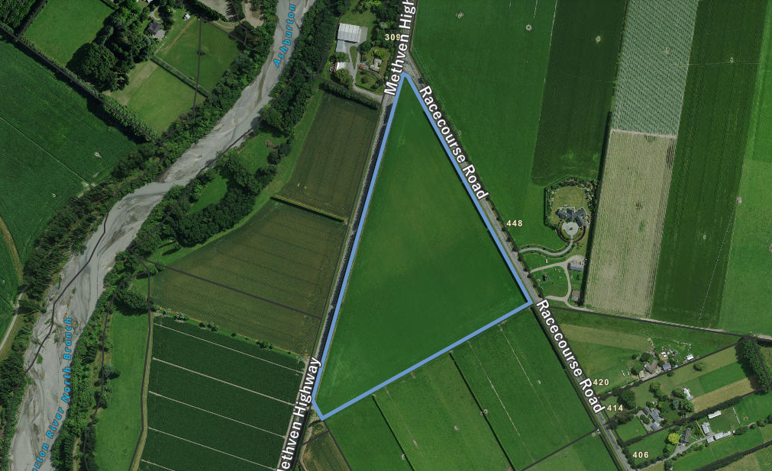

*Figure 2: Aerial Photograph of Application Site*

*Figure 3: Location of Application Site*

The property is grassed and currently grazed by cattle and has been identified as containing Class 2 soils. There are established shelterbelts around the perimeter of the site. State Highway 77 adjoins the western side of the property and Racecourse Road adjoins the eastern side. The two roads intersect at the northern tip of the site.

The wider area is characterised by a combination of rural productive and lifestyle properties. The north branch of the Ashburton River is approximately 170 metres to the northwest of the site.

**2.0 PLANNING FRAMEWORK**

2.1 RELEVANT RULES

The application site is zoned Rural A in the Ashburton District Plan. State Highway 77 also directly adjoins the western boundary of the application site (Designation D55). A copy of the District Plan map is attached as Figure 4 and the site is marked with a yellow star. It is noted that other designations, including D33, are with regards to river protection between the Ashburton River and associated floodbank (marked with a black line on Figure 4) :

*Figure 4: Ashburton District Plan Zone Map*

In applying the relevant provisions of the District Plan, the following definitions are considered relevant in determining the status of the proposed activity:

***Rural Activities***

*Means farming activities, intensive farming activities, and forestry activities.*

***Rural Service Activities***

*means any activity that provides a commercial service to a rural activity such as seed cleaning, rural contractors and grain drying.*

***Commercial Activity***

*means any activity trading in goods, equipment or services. It includes any ancillary activity to the commercial activity (for example administrative or head offices). Includes office activities, retail activities and commercial services.*

*It also includes recreational activities where a fee is paid to use facilities i.e. a commercial bowling alley. It does not include community sports facilities where a membership fee may be paid.*

***Commercial Services***

*means businesses that sell services rather than goods where a front counter service is provided to cater for walk in customers. For example: banks, real estate agents, travel agents, tattoo studios, dry cleaners and hairdressers.*

***Farming Activity***

*means the use of land and buildings for the primary purpose of the production of vegetative matter and/or commercial livestock.*

*Farming activity includes the packing, storage, and/or processing of the vegetative matter and/or commercial livestock produced on/in that land or on other land owned or managed by the same person(s). Buildings for this purpose are permitted up to an area of 500m² per site, where they meet all other rules.*

*Farming activity excludes residential activity, home occupations, intensive livestock management, and forestry activity.*

***Farming and agricultural supplier***

*businesses primarily selling goods for consumption or use in the business operations of primary producers or in animal husbandry.*

***Office***

*means any of the following:*

* *administrative offices where the administration of an organisation, whether trading or non-trading is conducted;*
* *commercial offices such as banks, insurance agents, typing services, duplicating services and real estate agents, being places where trade (other than that involving the immediate exchange of money for goods or the display or production of goods) is transacted;*
* *professional office such as the offices of accountants, solicitors, architects, surveyors and engineers, where a professional service is available and carried out.*

***Retail Activity***

*means the use of land or buildings for displaying or offering goods for sale or hire to the public and includes, but is not limited to, food and beverage outlets, small and large scale retail outlets, trade suppliers, yard based suppliers, second hand goods outlets and food courts.*

***Retail Sales***

*means the direct sale or hire to the public from any site and/or the display or offering for sale or hire to the public on any site of goods, merchandise or equipment. Retail sales includes restaurants, but excludes recreational activities.*

***Trade Supplier***

*Business engaged in sales to businesses, may include sales to general public, but wholly consists of sales in one or more of the following categories:*

* *Automotive and marine supplies;*
* *Building supplies;*
* *Garden and landscaping supplies;*
* *Farming and agricultural supplies;*
* *Hire services;*
* *Office furniture, equipment and systems supplies.*

In comparing the proposed activity to the above definitions, it is considered that the proposal is defined as follows:

* The areas used for the growing of seeds and the undertaking of plant trials including associated facilities, such as farm buildings are considered to align with the definition of a **Farming Activity**; and
* The areas and activities including head office, administrative facilities, associated storage, car parking and display of goods for visitors and customers to view are considered to align with the definition of a **Commercial Activity**.

On this basis resource consent is required for the following reasons:

* Rule 3.8.2(a) specifies that farming activities are provided for as a permitted activity;
* Rule 3.8.2(h) specifies that Commercial Activities; limited to group visits to sites used for farming or residential activities, are provided for as a permitted activity.
* Rule 3.8.2(p) specifies that Buildings are provided for as a permitted activity;
* Rule 3.8.6 (b) specifies that Commercial Activities are provided for as a Non-Complying activity;
* Site Standard 3.9.2 (Site Coverage) specifies that in the Rural A zone the maximum percentage/area of the net area of any site covered by buildings and impervious surfaces shall be 10% of net site area or 2000m², whichever is the lesser. In this instance, the combination of the proposed buildings and car parking areas will exceed 2,000m2. On this basis a Restricted Discretionary activity consent is required in accordance with Rule 3.8.4(a).
* Site Standard 3.9.10 (Retail Sales and Commercial Activities) specifies that rretail display and sales are limited to single retail outlets, not exceeding a gross floor area of 40m² and located within buildings and that group visits to sites used for farming or residential activities shall not result in the maximum number of vehicles visiting the site exceeding 3 buses per week and 25 cars per week. On the basis of an extensive planting area being available for display and the combination of activities resulting in more than 25 cars per week it is considered that the proposal will not comply with this standard. On this basis a Restricted Discretionary activity consent is required in accordance with Rule 3.8.4(a).
* Site Standard 3.9.13(b) (Earthworks) specifies that earthworks in the Rural A zone (excluding dig and fill for drainage works), shall not exceed a maximum volume of 5000m³ over an area no greater than 2000m² on any one site per annum. In order to form the site for the proposed buildings and associated car parking areas the permitted amount will be exceeded. On this basis a Restricted Discretionary activity consent is required in accordance with Rule 3.8.4(a).
* Standard 10.8.6 (Cycle Parking) specifies that all developments, other than residential and farming, are to provide cycle parking at a rate of 1 cycle space for every 20 car parking spaces provided. The applicant has advised that cycle parking will be determined at a later stage and that a precautionary approach has been taken in assuming the proposal will not comply with this standard.
* Standard 10.9.4 (Spacing between Vehicle Crossings) Racecourse Road is a Principal Road and is within a 100km/hr speed zone. On this basis the minimum spacing between successive vehicle crossings (regardless of the side of the road on which they are located) shall not be less than 200m. The proposed main vehicle crossing is immediately opposite one of the farming accesses of 448 Racecourse Road. This vehicle crossing is approximately 40m from the main access of 448 Racecourse Road. The proposed service vehicle crossing is approximately 150m from the main access of 448 Racecourse Road. The two proposed vehicle crossings are separated by approximately 190m. On this basis the proposal will not comply with these standards.

In assessing the above it is noted that the site has not been identified as potentially contaminated in the Environment Canterbury Listed Landuse Register and has not been identified as subject to flood risk in the District Plan maps.

Overall, the proposed activity is considered to be provided for as a non-complying activity under the provisions of the Ashburton District Plan.

1. **NOTIFICATION ASSESSMENT (SECTIONS 95A, 95C-95D)**

**3.1 PUBLIC NOTIFICATION ASSESSMENT**

**3.1.1 Request for public notification (Section 95A(2)(b)**

The applicant has not requested that the application be publicly notified

**3.1.2 National Environmental Standard or District Plan rule requiring or precluding notification (Section 95A(2)(c) and Section 95A(3)(a)**

In terms of s95A(2)(c) and 95A(3)(a) there are no rules in the relevant District Plan, Regional Plan or NES which require or preclude public notification of the application.

**3.1.3 Effects on the Environment to be disregarded (Section 95D Assessment)**

**3.1.3.1 Effects that must be disregarded for public notification purposes**

1. Effects on persons who own and occupy the land in, on or over which the application relates, or land adjacent to that land

In this case, it is considered that adjacent land includes the following, properties because they either directly adjoin the site or are located immediately opposite the subject site. The effects on these properties have been disregarded for the purposes of public notification assessment.

|  |  |  |
| --- | --- | --- |
|  | **Table 1** |  |
| **No.** | **Address** | **Legal Description** |
| 1. | Methven Highway | Lot 2 DP 415027 |
| 2. | Methven Highway | Lot 3 DP 415027 |
| 3. | 309 Methven Highway | Lot 4 DP 415027 |
| 4. | 448 Racecourse Road | PT RS 8053 BLK IX ASHBURTON SD |
| 5. | 420 Racecourse Road | LOT 1 D P 25200 BLK IX ASHBURTON SD |
| 6. | Racecourse Road | LOT 4 DP 439991 |
| 7. | 391 Racecourse Road | LOT 2 DP 439991 |
| 8. | 224 Methven Highway | LOT 1 DP 30597 BLK XII WESTERFIELD SD BLK IX ASHBURTON SD |
|  | State Highway 77 | State Highway |

Figure 1: Map showing the subject site and the sites termed as adjacent

The location of the identified properties are marked in orange in below Figure 5 (except for the State Highway). The number of each property aligns with the above table.

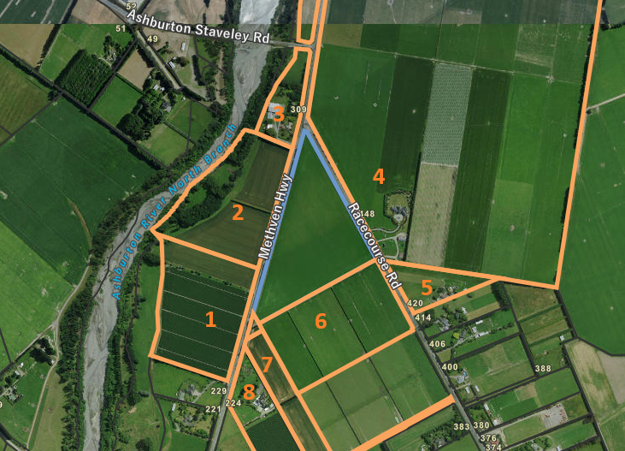

Figure 5: Location of Potentially Affected Parties

1. Any effect on a person who has given written approval to the application

No persons have given their written approval.

* + - 1. **Effects that may be disregarded – Permitted Baseline Assessment**

The permitted baseline refers to permitted activities on the subject site. In this case relevant permitted activities are considered to include the use of the property for farming activities, which could include the growing and testing of various seeds / plants, and the undertaking of group visits to the site. It is considered that these permitted activities are relevant elements or components in assessing the potential effects of the proposed activity.

This constitutes the permitted baseline and these adverse effects may be discounted entirely as the level of adverse effect arising from those permitted activities is deemed to be acceptable.  It is only any other or further adverse effects arising from the proposal over and above the permitted baseline which are to be assessed.

**3.1.4 Adverse Effects Assessment (Section 95A(2))**

Having regard to the above and after an analysis of the application, the following assessment addresses the adverse effects of the activity on the environment for public notification purposes.

As a non-complying activity the full range of adverse effects must be considered and accordingly the potential effects of the proposed activity have been assessed as follows:

**Amenity / Character**

Resource consent is sought to establish a facility for seed and plant research for agricultural purposes including seed and plant trials, display of products produced, office management and administration, operational storage, site landscaping and vehicle parking. The proposed will include rural elements but will also contain commercial elements associated with the head office and related facilities.

The combination and nature of activities assist in reducing potential effects of the proposed activity including some maintaining of a rural character and productive use of the property. The setting back of structures from the roads further assists in this regard.

While effects have been reduced it is still recognised that the use of the site and type of built form will be different from that associated with the general character of the local area. This includes a built form more readily associated with commercial activities and a larger car parking area. There will also be a higher frequency of vehicles entering and exiting the site, when compared to a typical rural activity.

It is considered that passersby and local neighbours will experience an amenity different from that which would be typically anticipated in the area. Mitigatory measures will assist but the change in character from the proposed activity is considered to be potentially more than minor in effect.

**Noise**

The applicant has confirmed that the proposed activity will comply with acoustic standards in the District Plan and any noise generated would align with typical agricultural productive activities, such as the operation of a tractor. It is also considered that the positioning of the proposed buildings assist in reducing effects.

For these reasons, any effects on the wider environment from noise associated with the proposed activity are considered to be less than minor. With regards to noise on local properties it is considered that the activity, particularly the car parking area, could have noise effects on the adjoining landowner directly adjoining the south boundary of the application site. That neighbouring property is an open paddock area that does not include a dwelling such that the sensitivity to effects is reduced but it is considered that potential effects on this party would be at least minor. It is also considered that the two neighbours nearer the main vehicle entrance to the site will be more sensitive to noise from vehicles entering and exiting the site such that there will also be minor noise effects on these two parties.

**Transport**

It is proposed to establish two vehicle crossings for access to the site. Both accesses will also be on to Racecourse Road. Vehicle access directly on to the State Highway has not been sought as part of the proposed activity. The applicant has estimated that the proposed activity could generate up to 166 vehicle movements per day and have also provided a traffic assessment for the proposed activity.

The assessment concludes that traffic effects from the proposed activity will be less than minor and it is agreed that effects are able to be suitably addressed, including in relation to the vehicle crossing on the opposite side of the road. In order to ensure traffic related effects will be suitably managed it will be necessary to impose appropriate conditions that require the vehicle crossings are suitably formed based on the nature of the proposed activity and number of anticipated vehicle movements.

**Services**

It is proposed that the activity will be serviced onsite including potable water being obtained from an existing well, wastewater disposed to ground and the establishment of stormwater management systems. The applicant has provided a technical assessment to confirm that such servicing is feasible subject to a detailed design being prepared at the appropriate time.

On the basis of the assessment provided it is agreed that the proposed activity can be suitably serviced subject to a detailed design being submitted, which can be required by way of condition of consent.

**Commercial Effects**

The resource consent application includes the establishment of the head office for Midlands Seeds which would be relocated from central Ashburton. The establishment of commercial activities outside of identified and zoned commercial areas has the potential to contribute to the fragmentation of commercial zones. In this instance it is recognised that the establishment of the head office on the application site would be done so in combination with the establishment of activities directly related to the office activities such that the activity would operate in conjunction with these other activities. This will lessen the scale of impact but it is recognised that if activities, like the proposed, were to establish in rural areas there will be an ongoing fragmentation of existing commercial areas within Ashburton. It is considered that the establishment of head offices outside of commercial areas is likely to lead to more than minor effects on the commercial fabric of Ashburton.

**Soils**

The application site contains class 2 soils and accordingly is within an area of highly productive land. It is accordingly relevant to assess the effects of the proposed activity on soils and the productivity of the site.

In this instance it is proposed to establish an activity which will continue the productive use of the site and this will remain the primary use of the site. It is also recognised that the growing and testing of crops on the site will lead to wider rural productivity on a global scale. The proposed activity will result in a loss of some productive land through the establishment of structures and car parking areas, and not all of those structures will be directly related to activities on the site such that it is considered that there will be some effects on the productivity of the site.

The application site is just over eight hectares in area such that it is recognised that the scale of existing productivity on the site is more limited and that it will only be a smaller portion of the site which would be used for activities not directly related to the productive use of the property. On this basis it is considered that any effect will be at least minor but is unlikely to be more than minor.

***Summary***

In summary, having assessed the adverse effects of the activity on the environment, I consider that the activity will overall have a more than minor adverse effects on the environment as discussed in section 3.1.4.

* + 1. **Do special circumstances exist (Section 95A(4))?**

It is considered that no special circumstances exist in relation to the application.

**LIMITED NOTIFICATION ASSESSMENT**

**4.1.1 Is there an NES or District Plan rule requiring limited notification?**

There are no rules in the relevant District Plan/ Regional Plan/NES that would require or preclude limited notification of the application.

**4.1.2 Are there holder(s) of customary rights order who may be adversely affected by the activity? (s 95(f))?**

No

**4.1.3 Are there affected persons who the activity will have a minor or more than minor adverse effects on (s 95 (e))?**

Written approval has not been obtained from all the persons who are considered to be adversely affected by the activity, as such, the application is required to be subject to limited notification.

**4.1.4 Limited Notification Assessment Conclusion**

It is considered that this application should be processed with service of notice as some affect persons have not given their written approval to this proposed activity but it is recognised that it has been established that the effects of the activity will be more than minor on the wider environment such that the application will need to be processed on a fully publicly notified basis regardless of the assessed effects on specific parties.

**6.0 Conclusion**

**Public Notification**

* This application must be publicly notified because the activity will have, or is likely to have, adverse effects on the environment that are more than minor as detailed in Section 3.1.4.

**7.0 Recommendation**

**Public Notification**

That for the reasons set out below, this application be processed with public notification pursuant to Sections 95A-95F of the Resource Management Act 1991.

1. The effects are more than minor (s.95D)

**Signed: Date:** 14 May 2025Stewart Fletcher  
Reporting Planner

**Decision:**

The above application LUC25/0001 has been considered under delegated authority and has been determined to be processed with public notice pursuant to sections 95A-95F of the Resource Management Act 1991.

**Signed:** **Date:**

Brad Thomson

District Planning Manager

**Signed:** **Date:**

Ian Hyde

Group Manager Compliance & Development